“Online Government Scheme Health Portal”

A Synopsis Report

Submitted in Partial Fulfillment of requirements for the Award of Degree of Bachelor of Engineering in Computer Science & Engineering



RAJIV GANDHI PROUDYOGIKI VISHWAVIDYALAYA, BHOPAL (M.P)

Submitted By

Name’s – SHUBHAM SINGH SAGWALIYA
SURAJ SAHU
POOJA MISHRA
NEHA YADAV
SWASTIK MAURYA

Under the guidance of
Prof. Rakesh Tiwari



DEPARTMENT OF COMPUTER SCIENCE & ENGINEERING
RADHARAMAN ENGINEERING COLLEGE,
BHOPAL (M.P.)

SESSION: 2018-2019

CERTIFICATE

This is to certify that SHUBHAM SINGH SAGWALIYA Roll no. 0158CS161051 of 7th semester B.E. Computer Science & Engineering from Radharaman Engineering College, Bhopal has successfully completed his/her synopsis report of the under assigned topic of “Online Government Health Scheme Portal ”.
The synopsis report is hereby approved for submission towards partial fulfillment for the award of degree in B.E. Computer Science & Engineering from Radharaman Institute of Technology and Science, Bhopal.

Under the guidance of  Prof. Rakesh Tiwari  CSE, REC | Head of Department  Prof Mukesh Dixit  CSE, REC

ACKNOWLEDGEMENT

We express our deep sense of gratitude to our respected and learned guides, Prof. Rakesh Tiwari for their valuable help and guidance, we are thankful to them for the encouragement they have given us in completing the project.

We are also grateful to respected Prof Mukesh Dixit, HOD (CSE) and to our respected Dr. Anurag Jain, Director R.E.C. Bhopal for permitting us to utilize all the necessary facilities of the institution.

We are also thankful to all the other faculty & staff members of our department for their kind co-operation and help.

Lastly, we would like to express our deep apperception towards our classmates and our indebt ness to our parents for providing us the moral support and encouragement.

SHUBHAM SINGH SAGWALIYA
0158CS161051

DECLARATION

I declare that the work that is being presented in the synopsis report entitled “Online Government Health Scheme Portal” in partial fulfillment of the requirement for the award of degree of Bachelor of Engineering in Computer Science & Engineering from Radharaman Engineering College, Bhopal authentic record of our own work carried out under the guidance of GUIDE Prof. Rakesh Tiwari.
The matter embodied in the report has not been submitted for the award of any other degree or diploma.

SHUBHAM SINGH SAGWALIYA 0158CS161051

PREFACE

The Project entitled "Online Government Scheme Health Portal" is a web application. Developed in PHP LANGUAGE using PHP as front-end and MYSQL as back-end on Windows Operating System. The Online Government Scheme Health web application where people get to know about the all the necessary information regarding any health related & medical issues.

It will enable user to browse through the web application and get all information about the doctor, hospital, disease and schemes at one place. The administration module will enable a system administrator to approve and reject requests for new orders and maintain various lists of order category.

The proposed system is a web application. It can be accessed by anywhere in the world. The proposed system would overcome the communication gap between doctor and patient. The proposed system also establishes a direct communication between the patients and medical experts. With this both have an understanding and resolve issues directly without any third-party mediators.
Table of Contents

Chapter 1
- Introduction to the topic
- Brief description of company
- Features of Project
- Objective
- Research Design
- Hypothesis
Chapter 2
- Data Collection
- Algorithm
- Flow Chart
- DFD
- ER Diagram
Chapter 3
- Requirement Specification
- (H/W&S/W)
- Description of Software used
- Description of Data Base
Chapter 4
- Limitation of Study
- Significance of the Study
- Justification of the Study
Chapter 5
- System Implementation
- Future Enhancement
- Features and Uniqueness
Chapter 6
- Testing
- Reports
- Output
Chapter 7
- Conclusion
- Suggestion

CHAPTER I

Introduction to the topic :

Project Title: “Online Government Health Scheme Portal”

Over View of Project:

The proposed system is a web application. It can be accessed by anywhere in the world. The proposed system has to overcome the manual working and fully automate it. The proposed system builds a direct communication which focuses on reducing gap between patients and doctors. With this both have an understanding and maintain their deals directly without any issues.

Brief description of company:
The central concept of the application is to enable the People to buy products online without going to workshop personally. Online Government Health Scheme Portal is aimed towards the vendors who want to reach out to the maximum cross-section of customer and common people who can be potential customer. This project envisages bridging the gap between the seller and the customer. It should be user-friendly, ‘quick to learn’ and reliable software for the above purpose. It is intended to be a stand-alone product and should not depend on the availability of other software. It should run on both UNIX and Windows based the application is designed into two modules:-

Feature of project :
- Connectivity and Reachability to the people would get more reliable and promising using this platform.
- Medical issues would get resolved using SSDTS(Smart Self Diagnosis Test System).
- Adding of more government scheme for relaxation of rural people.
- Expanding into other states.
- ~ 50,000+ people would be getting benefit by using our website.
- Customer Care Support would get possible.
- More online medical services will be provided
OBJECTIVE :

Our objective is to create a free online platform where rural people could be enlightened about their health issues easily. An online platform where people could get all information about the doctor, hospital, disease and schemes at one place. To provide essential information. Provide online solution through medical expert. It is a free online platform which focuses on reducing gap between patients and doctors. Platform where people can search for a particular doctor, hospital, disease and schemes for cheap & effective treatment at one place. A website where people get to know about the all the necessary information regarding any health related & medical issues. It is convenient & easy to be accessing website for patient and doctors. The primary aim is to provide a centralize solution.

Research Methodology :

The process used to collect information and data for the purpose of making business decisions, the methodology may include publication research, interviews, surveys and other research techniques, and could include both present and historical information.
Research has been defined in a number of different ways and while their similarities, tare does not appear to be a single no all-encompassing definition that is impressed by all who engage in it.

Forms of Research:
- Original Research
- Scientific Research
- Artistic Research
Methodology:

It is the systematic theoretical analysis of the methods applied to a field of study. It Comprises theoretical analysis of the body of methods and principals associated with a branch of Knowledge. Typically, it encompasses concepts such as paradigm, theoretical model, phases and quantitative or qualitative techniques.

A methodology does not set out to provide solutions-it is therefore, not the same as a method. Instead, a methodology offers the theoretical underpinning for understanding which method, set of methods, or best practices can be applied to a specific case, for example, to calculate a specific result.

It has been defined also as follows:

- “the analysis of the principles of methods, rules, and postulates employed by a discipline”,
- “the systematic study of methods that are, can be, or have been applied within a discipline,”
- “the study or description of methods”

Research Design:

Definition :

Research design is defined as a framework of methods and techniques chosen by a researcher to combine various components of research in a reasonably logical manner for that the research problem is efficiently handled. It provides insights about “how” to conduct research using a particular methodology. Every research has a list of research questions which need to be assessed – this can be done with research design.

The essential elements of research design are:
- Accurate purpose statement of research design
- Techniques to be implemented for collecting details for research
- Method applied for analysing collected details
- Type of research methodology
- Probable objection for research
- Settings for research study
- Timeline
- Measurement of analysis
Type of Research:

- Qualitative Research Design
- Quantitative Research Design
Further, research design can be divided into five types –

- Descriptive Research Design
- Experimental Research Design
- Correlational Research Design
- Diagnostic Research Design

SDLC:

SDLC is a process followed for a software project, within a software organization. It consists of a detailed plan describing how to develop, maintain, replace and alter or enhance specific software. The life cycles a methodology for improving the quality of software and the overall development process.

SDLC phases

Phase 1:Requirement collection and analysis
Phase 2:Feasibility
Phase 3:Design
Phase 4:Coding
Phase 5:Testing
Phase 6:Installation/Deployment
Phase 7:Maintenance

Phase 1: Requirement collection and analysis

The requirement is tougher state in the SDLC process. It is conducted by the senior team members with inputs from all the stakeholders and domain experts in the industry. Planning for the quality assurance requirements and recognition of the risks involved is also done at this stage.

This stage gives a clearer picture of the scope of the entire project and the anticipated issues, opportunities, and directives which triggered the project.

Requirements Gathering stage need teams to get detailed and precise requirements. This helps companies to finalize the necessary timeline to finish the work of that system.

Phase 2: Feasibility

Once the requirement analysis phase is completed the next step is to define and document software needs. This process conducted with the help of “Software requirement specification” document also known as SRS document. It includes everything which should be designed and nocturia project life cycle.

There are five types of feasibilities checks:

- Economic
- Legal
- Operation feasibility
- Technical
- Schedule
Phase 3: Design

In this third phase, the system and software design documents are prepared as per the requirement specification document. This helps define overall system architecture.

This design phase serves as input for the next phase of the model.

There are two kinds of design documents developed in this phase:
- High-level Design
- Low-level Design

Phase 4: Coding

The programming code is generated as per DDS during this stage. If the design is performed in a detailed and organized manner, code generation can be accomplished without much hassle.
Developers must follow the coding guidelines defined by their organization and programming tools like compilers, interpreters, debuggers, etc. are used to generate the code. Different high-level programming languages such as C, C++, Pascal, Java and PHP are used for coding. The programming language is chosen with respect to the type of software being developed.

Phase 5: Testing

This stage is usually a subset of all the stages as in the modern SDLC models, the testing activities are mostly involved in all the stages of SDLC. However, this stage refers to the testing only stage of the product where product defects are reported, tracked, fixed and retested, until the product reaches the quality standards defined in the SRS.

Phase 6: Installation/Deployment

Once the product is tested and ready to be deployed it is released formally in the appropriate market. Sometimes product deployment happens in stages as per the business strategy of that organization. The product may first be released in a limited segment and tested in the real business environment (UAT- User acceptance testing).
Then based on the feedback, the product may be released as it is or with suggested enhancements in the targeting market segment.

Phase7: Maintenance

After the product is released in the market, its maintenance is done for the existing customer base.

CHAPTER II

Data Collection :

Definition : Data collection is the process of gathering and measuring information on targeted variables in an established system, which then enables one to answer relevant questions and evaluate outcomes. Data collection is a component of research in all fields of study including physical and social sciences, humanities and business. While methods vary by discipline, the emphasis on ensuring accurate and honest collection remains the same. The goal for all data collection is to capture quality evidence that allows analysis to lead to the formulation of convincing and credible answers to the questions that have been posed.

Data Collection Techniques
Interviews

- Interviews can be conducted in person or over the telephone
- Interviews can be done formally (structured), semi-structured, or informally
- Questions should be focused, clear, and encourage open-ended responses
- Interviews are mainly qualitative in nature

Questionnaires and Surveys

- Responses can be analysed with quantitative methods by assigning numerical values to Likert-type scales
- Results are generally easier (than qualitative techniques) to analyse
- Pretest/Posttest can be compared and analysed

Observations

- Allows for the study of the dynamics of a situation, frequency counts of target behaviours, or other behaviours as indicated by needs of the evaluation
- Good source for providing additional information about a particular group, can use video to provide documentation
- Can produce qualitative (e.g., narrative data) and quantitative data (e.g., frequency counts, mean length of interactions, and instructional time)

Focus Groups

- A facilitated group interview with individuals that have something in common
- Gathers information about combined perspectives and opinions
- Responses are often coded into categories and analysed thematically

Ethnographies, Oral History, and Case Studies
- Involves studying a single phenomenon
- Examines people in their natural settings
- Uses a combination of techniques such as observation, interviews, and surveys
- Ethnography is a more holistic approach to evaluation
- Researcher can become a confounding variable
Documents and Records
- Consists of examining existing data in the form of databases, meeting minutes, reports, attendance logs, financial records, newsletters, etc.
- This can be an inexpensive way to gather information but may be an incomplete data source
Algorithm :

An algorithm is a formula or set of steps for solving a particular problem. To be an algorithm, a set of rules must be unambiguous and have a clear stopping point. Algorithms can be expressed in any language, from natural languages like English or French to programming languages like FORTRAN.

As an effective method, an algorithm can be expressed within a finite amount of space and time and in a well-defined formal language for calculating a function. Starting from an initial state and initial input (perhaps empty), the instructions describe a computation that, when executed, proceeds through a finite number of well-defined successive states, eventually producing "output" and terminating at a final ending state. The transition from one state to the next is not necessarily deterministic; some algorithms, known as randomized algorithms, incorporate random input.

Algorithm design refers to a method or mathematical process for problem-solving and engineering algorithms. The design of algorithms is part of many solution theories of operation research, such as dynamic programming and divide-and-conquer. Techniques for designing and implementing algorithm designs are also called algorithm design patterns, such as the template method pattern and decorator pattern.
One of the most important aspects of algorithm design is creating an algorithm that has an efficient run-time, also known as its Big O.

Typical steps in the development of algorithms:
- Problem definition
- Development of a model
- Specification of the algorithm
- Designing an algorithm
- Checking the correctness of the algorithm
- Analysis of algorithm
- Implementation of algorithm
- Program testing
- Documentation preparation

Flowchart
A flowchart is a type of diagram that represents an algorithm, workflow or process. Flowchart can also be defined as a diagrammatic representation of an algorithm (step by step approach to solve a task).

The flowchart shows the steps as boxes of various kinds, and their order by connecting the boxes with arrows. This diagrammatic representation illustrates a solution model to a given problem. Flowcharts are used in analyzing, designing, documenting or managing a process or program in various fields.

Flowcharts are used in designing and documenting simple processes or programs. Like other types of diagrams, they help visualize what is going on and thereby help understand a process, and perhaps also find less-obvious features within the process, like flaws and bottlenecks. There are different types of flowcharts: each type has its own set of boxes and notations. The two most common types of boxes in a flowchart are:

a processing step, usually called activity, and denoted as a rectangular box.
a decision usually denoted as a diamond.

A flowchart is described as "cross-functional" when the chart is divided into different vertical or horizontal parts, to describe the control of different organizational units. A symbol appearing in a particular part is within the control of that organizational unit. A cross-functional flowchart allows the author to correctly locate the responsibility for performing an action or deciding, and to show the responsibility of each organizational unit for different parts of a single process.

Flowcharts depict certain aspects of processes and are usually complemented by other types of diagram. For instance, Kaoru Ishikawa defined the flowchart as one of the seven basic tools of quality control, next to the histogram, Pareto chart, check sheet, control chart, cause-and-effect diagram, and the scatter diagram. Similarly, in UML, a standard concept-modeling notation used in software development, the activity diagram, which is a type of flowchart, is just one of many different diagram types.

Nassi-Shneiderman diagrams and Drakon-charts are an alternative notation for process flow.

Common alternative names include flow chart, process flowchart, functional flowchart, process map, process chart, functional process chart, business process model, process model, process flow diagram, work flow diagram, business flow diagram. The terms "flowchart" and "flow chart" are used interchangeably.

The underlying graph structure of a flowchart is a flow graph, which abstracts away node types, their contents and other ancillary information.

Types
- Document flowcharts, showing controls over a document-flow through a system
- Data flowcharts, showing controls over a data-flow in a system
- System flowcharts, showing controls at a physical or resource level
- Program flowchart, showing the controls in a program within a system

Common symbols

ANSI/ISO Shape | Name | Description
 | Flowline (Arrowhead) | Shows the process's order of operation. A line coming from one symbol and pointing at another. Arrowheads are added if the flow is not the standard top-to-bottom, left-to right.
 | Terminal | Indicates the beginning and ending of a program or sub-process. Represented as a stadium, oval or rounded (fillet) rectangle. They usually contain the word "Start" or "End", or another phrase signaling the start or end of a process, such as "submit inquiry" or "receive product".
 | Process | Represents a set of operations that changes value, form, or location of data. Represented as a rectangle.
 | Decision | Shows a conditional operation that determines which one of the two paths the program will take. The operation is commonly a yes/no question or true/false test. Represented as a diamond (rhombus).
 | Input/output | Indicates the process of inputting and outputting data, as in entering data or displaying results. Represented as a parallelogram.
 | Annotation (Comment) | Indicating additional information about a step the program. Represented as an open rectangle with a dashed or solid line connecting it to the corresponding symbol in the flowchart.
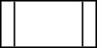 | Predefined Process | Shows named process which is defined elsewhere. Represented as a rectangle with double-struck vertical edges.
 | On-page Connector | Pairs of labeled connectors replace long or confusing lines on a flowchart page. Represented by a small circle with a letter inside.
 | Off-page Connector | A labeled connector for use when the target is on another page. Represented as a home plate-shaped pentagon.

Data-flow diagram
A data-flow diagram (DFD) is a way of representing a flow of a data of a process or a system (usually an information system) The DFD also provides information about the outputs and inputs of each entity and the process itself. A data-flow diagram has no control flow, there are no decision rules and no loops. Specific operations based on the data can be represented by a flowchart.
There are several notations for displaying data-flow diagrams. The notation presented above was described in 1979 by Tom DeMarco as part of Structured Analysis.
For each data flow, at least one of the endpoints (source and / or destination) must exist in a process. The refined representation of a process can be done in another data-flow diagram, which subdivides this process into sub-processes.
The data-flow diagram is part of the structured-analysis modelling tools. When using UML, the activity diagram typically takes over the role of the data-flow diagram. A special form of data-flow plan is a site-oriented data-flow plan.
Data-flow diagrams can be regarded as inverted Petri nets, because places in such networks correspond to the semantics of data memories. Analogously, the semantics of transitions from Petri nets and data flows and functions from data-flow diagrams should be considered equivalent.

DFD components
DFD consists of processes, flows, warehouses, and terminators. There are several ways to view these DFD components.
Process
The process (function, transformation) is part of a system that transforms inputs to outputs. The symbol of a process is a circle, an oval, a rectangle or a rectangle with rounded corners (according to the type of notation). The process is named in one word, a short sentence, or a phrase that is clearly to express its essence.
Data Flow
Data flow (flow, dataflow) shows the transfer of information (sometimes also material) from one part of the system to another. The symbol of the flow is the arrow. The flow should have a name that determines what information (or what material) is being moved. Exceptions are flows where it is clear what information is transferred through the entities that are linked to these flows. Material shifts are modelled in systems that are not merely informative. Flow should only transmit one type of information (material). The arrow shows the flow direction (it can also be bi-directional if the information to/from the entity is logically dependent - e.g. question and answer). Flows link processes, warehouses and terminators.
Warehouse
The warehouse (datastore, data store, file, database) is used to store data for later use. The symbol of the store is two horizontal lines, the other way of view is shown in the DFD Notation. The name of the warehouse is a plural noun (e.g. orders) - it derives from the input and output streams of the warehouse. The warehouse does not have to be just a data file, for example, a folder with documents, a filing cabinet, and optical discs. Therefore, viewing the warehouse in DFD is independent of implementation. The flow from the warehouse usually represents the reading of the data stored in the warehouse, and the flow to the warehouse usually expresses data entry or updating (sometimes also deleting data). Warehouse is represented by two parallel lines between which the memory name is located (it can be modelled as a UML buffer node).
Terminator
The Terminator is an external entity that communicates with the system and stands outside of the system. It can be, for example, various organizations (e.g. a bank), groups of people (e.g. customers), authorities (e.g. a tax office) or a department (e.g. a human-resources department) of the same organization, which does not belong to the model system. The terminator may be another system with which the modelled system communicates.

DFD of our project :

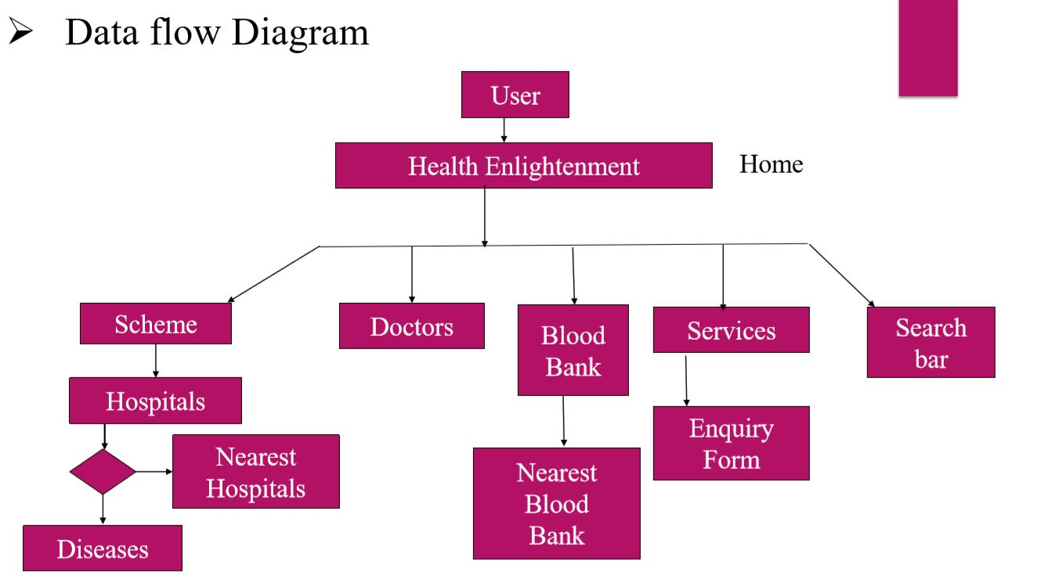

E-R Diagram:-
An entity-relationship model (ERM) is an abstract and conceptual representation of data. Entity-relationship modeling is a database modeling method, used to produce a type of conceptual schema or semantic data model of a system, often a relational database, and its requirements in a top-down fashion. Diagrams created by this process are called entity-relationship diagrams, ER diagrams, or ERDs.
The building blocks: entities, relationships, and attributes:-
An entity-relationship (ER) diagram is a specialized graphic that illustrates the interrelationships between entities in a database. ER diagrams often use symbols to represent three different types of information. Boxes are commonly used to represent entities. Diamonds are normally used to represent relationships and ovals are used to represent attributes.
Also Known As: ER Diagram, E-R Diagram, entity-relationship model

There are three types of relationships between entities:
- One-to-one: one instance of an entity (A) is associated with one other instance of another entity (B). For example, in a database of employees, each employee name (A) is associated with only one social security number (B).
- One-to-many: one instance of an entity (A) is associated with zero, one or many instances of another entity (B), but for one instance of entity B there is only one instance of entity A. For example, for a company with all employees working in one building, the building name (A) is associated with many different employees (B), but those employees all share the same singular association with entity A.
- Many-to-many: one instance of an entity (A) is associated with one, zero or many instances of another entity (B), and one instance of entity B is associated with one, zero or many instances of entity A. For example, for a company in which all of its employees work on multiple projects, each instance of an employee (A) is associated with many instances of a project (B), and at the same time, each instance of a project (B) has multiple employees (A) associated with it.
Use Case:-
Using UML notation, a diagrammatic representation of a use-case, called a use-case diagram can be created. Like many elements of the analysis model, the use-case diagram can be represented at many levels of abstraction. The use-case diagram contains actors and use-cases. Actors are entities that interact with the system. They can be human users or other machines or systems that have defined interfaces to the software.
A use case diagram shows a set of use cases and actors (a special kind of class) and their relationships. Use case diagrams address the static use case view of a system.
These diagrams are especially important in organizing and modeling the behaviors of a system

“A use case specifies the behavior of a system or a part of a system and is a description of a set of sequences of actions, including variants, that a system performs to yield an observable result of value to an actor.”
“An actor is an idealization of an external person, process, or thing interacting with a system, subsystem, or class. An actor characterizes the interactions that outside users may have with the system.”

Sequence Diagram:-
Both sequence diagrams and collaboration diagrams are kinds of interaction diagrams.
A show an interaction, consisting of a set of objects and their relationships, including
the messages that may be dispatched among them. Interaction diagrams address the
dynamic view of a system. A sequence diagram is an interaction diagram that
emphasizes the time-ordering of messages; a collaboration diagram is an interaction
diagram that emphasizes the structural organization of the objects that send and receive
messages. Sequence diagrams and collaboration diagrams are isomorphic, meaning that you can take one and transform it into the other.
Activity Diagram:-
An activity diagram is a special kind of a state chart diagram that shows the flow from activity to activity within a system. Activity diagrams address the dynamic view of a system. They are especially important in modeling the function of a system and emphasize the flow of control among objects.

E-R Diagram of our project :

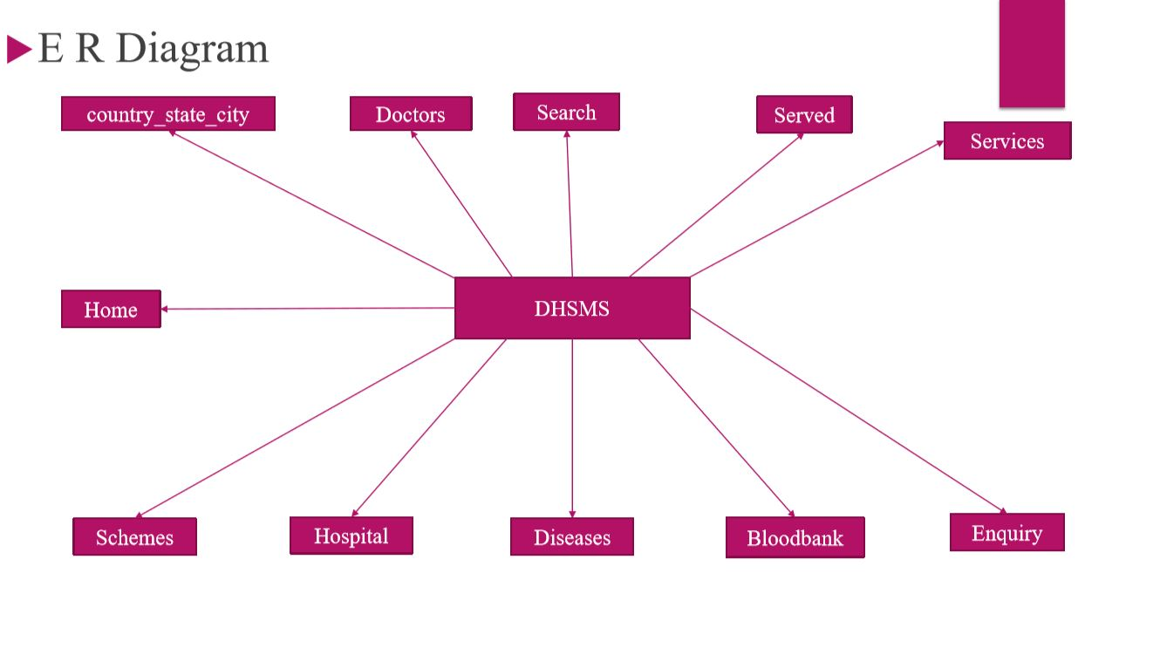

CHAPTER III

Requirement Specification:
The output of the requirements phase of the software development process is Software Requirements Specification (SRS) (also known as requirements document). This document lays a foundation for software engineering activities and is created when entire requirements are elicited and analysed. SRS is a formal document, which acts as a representation of software that enables the users to review whether it (SRS) is according to their requirements. In addition, it includes user requirements for a system as well as detailed specifications of the system requirements.
SRS is used by various individuals in the organization. System customers need SRS to specify and verify whether requirements meet the desired needs. In addition, SRS enables the managers to plan for the system development processes. System engineers need a requirements document to understand what system is to be developed. These engineers also require this document to develop validation tests for the required system. Lastly, requirements document is needed by system maintenance engineers to use the requirement and the relationship between its parts.
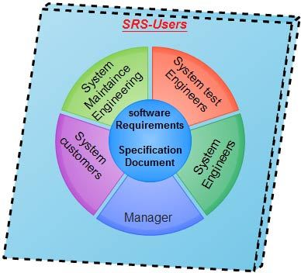
The requirements document has diverse users. Therefore, along with communicating the requirements to the users it also has to define the requirements in precise detail for developers and testers. In addition, it should also include information about possible changes in the system, which can help system designers avoid restricted decisions on design. SRS also helps maintenance engineers to adapt the system to new requirements.

SRS divide in mainly in two types:
Functional Requirements: It should describe all requirement functionality or system services. The customer should provide statement of service. it should be clear how the system should be reacting to particular input and how a particular system should behave in particular situation. Functional requirement is heavily depending upon he types of software expected users and the type of system where the software is used. It describes system services in detail.
- First page is home page which elaborated or directed for whole website by available here a video and some slides.
- Second one is scheme page which show all government health schemes state wise
- Third one is hospital page which user nearby hospital on their requirement.
- Fourth one is disease page which show or define diseases which come under government health scheme.
- Fifth one is doctors page which show details of doctors who are specialist in his profession.
- Sixth one is Blood bank page where we show nearby Blood bank details of user on their requirements.
- Last one service page it’s a like self-diagnose system user fill its problem or requirement then they get their problem solution by expertise.

Non -Functional Requirements: Requirements, which are not related to functional aspect of software, fall into this category. They are implicit or expected characteristics of software; which users make assumption of. Non -functional are more critical than functional requirement if the non-functional requirement do not meet then the complete system is of no
Use.
- Regular updates for all government health schemes for user.
- Reply of doctors at a time on user demand.

H/W & S/W
Hardware: There is no documentation on the minimum specs needed to run WAMP but as long as your laptop can run Windows, MySQL and PHP then there would be no problem running WAMP.

Minimum Hardware Requirements
This section describes the minimum hardware requirements for the Enterprise Service Monitor.
- 2 CPU Cores
- 2 GB RAM
- Disk I/O subsystem applicable to a write-intensive database

Recommended Hardware Requirements
This section describes the recommended hardware requirements for the Enterprise Service Manager.
- 4 CPU Cores or more
- 8 GB RAM or more
- RAID10 or RAID 0+1 disk setup

Software: Everything is managed by the WampServer installer. By default, WampServer comes with the latest versions of Apache, MySQL and PHP.
Once installed, you will be able to manually add additional versions of Apache, PHP or MySQL (only compiled VC9, VC10 or VC11). The explanations for doing so will be given on the forum.
Each version of Apache, MySQL and PHP has its own configuration and its own files (data for MySQL).

Description of Software used:
WAMP Server: Stands for "Windows, Apache, MySQL, and PHP." WAMP is a variation of LAMP for Windows systems and is often installed as a software bundle (Apache, MySQL, and PHP). It is often used for web development and internal testing but may also be used to serve live websites.
The most important part of the WAMP package is Apache (or "Apache HTTP Server") which is used run the web server within Windows. By running a local Apache web server on a Windows machine, a web developer can test webpages in a web browser without publishing them live on the Internet.
WAMP also includes MySQL and PHP, which are two of the most common technologies used for creating dynamic websites. MySQL is a high-speed database, while PHP is a scripting language that can be used to access data from the database. By installing these two components locally, a developer can build and test a dynamic website before publishing it to a public web server.
While Apache, MySQL, and PHP are open source components that can be installed individually, they are usually installed together. One popular package is called "WampServer," which provides a user-friendly way to install and configure the "AMP" components on Windows.
NOTE: The "P" in WAMP can also stand for either Perl or Python, which are other scripting languages. The Mac version of LAMP is known as MAMP.

Sublime Text: Sublime Text is a proprietary cross-platform source code editor with a Python application programming interface (API). It natively supports many programming languages and mark-up languages, and functions can be added by users with plugins, typically community-built and maintained under free-software licenses.
Features:
The following is a list of features of Sublime Text:^{[4]}
- "Goto Anything," quick navigation to files, symbols, or lines
- "Command palette" uses adaptive matching for quick keyboard invocation of arbitrary commands
Simultaneous editing: simultaneously make the same interactive changes to multiple selected areas
- Python-based plugin API
- Project-specific preferences
- Extensive customizability via JSON settings files, including project-specific and platform-specific settings
- Cross-platform (Windows, macOS, and Linux) and Supportive Plugins for cross-platform
- Compatible with many language grammars from Text Mate.

Web Browser:
A web browser is a software program that allows a user to locate, access, and display web pages. In common usage, a web browser is usually shortened to "browser." Browsers are used primarily for displaying and accessing websites on the internet, as well as other content created using languages such as Hypertext Mark-up Language (HTML) and Extensible Mark-up Language (XML).
Browsers translate web pages and websites delivered using Hypertext Transfer Protocol (HTTP) into human-readable content. They also have the ability to display other protocols and prefixes, such as secure HTTP (HTTPS), File Transfer Protocol (FTP), email handling (mailto:), and files (file:). In addition, most browsers also support external plug-ins required to display active content, such as in-page video, audio and game content.

A variety of web browsers are available with different features and are designed to run on different operating systems. Common browsers include Internet Explorer from Microsoft, Firefox from Mozilla, Google Chrome, Safari from Apple, and Opera. All major browsers have mobile versions that are lightweight versions for accessing the web on mobile devices.
Web browsers date back to the late 1980s when an English scientist, Tim Berners-Lee, first developed the ideas that led to the World Wide Web (WWW). This consisted of a series of pages created using the HTML language and joined or linked together with pointers called hyperlinks. Following this was the need for a program that could access and display the HTML pages correctly – the browser.
In 1993, a new browser known as Mosaic was developed, which soon gained widespread usage due to its graphical-interface capability. Marc Andreesen, a member of the Mosaic development team, left in 1994 to develop his own commercial browser based on Mosaic. He called it Netscape Navigator, and it quickly captured over 90 percent of the nascent browser market. It soon faced stiff competition in 1995 from Microsoft's Internet Explorer, which was freely bundled with Windows 95 (and later versions of Windows). It was pointless to buy Navigator when Internet Explorer was free, and as a result, Navigator (and Netscape) were driven into the ground. But while Mosaic and Netscape are no longer around, the age of the browser was launched and continues to this day, as more and more applications move to the web.

Description of Data Base:

With PHP, you can connect to and manipulate databases.
MySQL is the most popular database system used with PHP.

What is MySQL?
- MySQL is a database system used on the web
- MySQL is a database system that runs on a server
- MySQL is ideal for both small and large applications
- MySQL is very fast, reliable, and easy to use
- MySQL uses standard SQL
- MySQL compiles on a number of platforms
- MySQL is free to download and use
- MySQL is developed, distributed, and supported by Oracle Corporation
- MySQL is named after co-founder Monty Widenius's daughter: My
The data in a MySQL database are stored in tables. A table is a collection of related data, and it consists of columns and rows.
Databases are useful for storing information categorically. A company may have a database with the following tables:
- Doctors
- Hospitals
- Blood Bank

CHAPTER IV

Limitation of Study:
A constraint, in project management, is any restriction that defines a project's limitations; the scope, for example, is the limit of what the project is expected to accomplish.
The three most significant project constraints -- schedule, cost and scope -- are sometimes known as the triple constraint or the project management triangle. A project’s scope involves the specific goals, deliverables and tasks that define the boundaries of the project. The schedule (sometimes stated more broadly as time) specifies the timeline according to which those components will be delivered, including the final deadline for completion. Cost (sometimes stated more broadly as resources) involves the financial limitation of resources input to the project and also the overall limit for the total amount that can be spent.
Project constraints are also considered to be somewhat mutually exclusive. In the project management triangle, it is assumed that making a change to one constraint will affect one or both of the others. For example, increasing the scope of the project is likely to require more time and money.
That reality is also expressed as the pick two principle, which maintains that for any given set of three desired qualities or expectations -- such as "good, fast and cheap" -- it is likely that only two can coexist: A given product might be delivered quickly and inexpensively, for example, but the quality will suffer.
Limitation of our Projects is:

- It will growth slowly because it depends on use of Internet by user and awareness.
- We are dependent on doctors reply for user which we have no control.
- As per Government health scheme increase our project growth well.
- Regular updates in our web application is must.
- And regularly innovative things involvement wants.

Significance of the study:
We know many of the government schemes running for relaxation of rurales and poor people. Health is very important for developing country as per government also take action but rate of illiteracy of people are create complication for taking benefit of any schemes, sometimes people are fraud.
In a solution these complicated problems we make a website that we want reach people, by the use of this website person know about which benefit for him hospital doctor and schemes in health-related issues his not aware. Here we provide platform were people go and search for him particular doctor, hospital, disease and schemes .If person search by used in one of them he/she all of these locations wise. Let’s we take a example, suppose people live in a Bhopal dist/. Huzur tehsil goal village. Its distance from about 20 to 25 km. he have problem in stomach pain for a week he take medicine from mohalla clinic but it’s not well someone says, why don’t go for treatment Bhopal where you can get good treatment , no its very costly for me, no I can give proper information where you can take as very cheap rate where, I know one website where I got this information how you know about this website my younger brother told me , he live in a Bhopal for learning. When my father was ill ok you can give information about doctor, hospital and schemes which benefit, for me yes I can give.
Rural health care is one of the biggest challenges facing the government of India. With more than 70% population living in rural areas where the condition of medical facilities is deplorable. So, the rural peoples are the most target beneficiary group in our innovation. It is very simple & easy to use product for rural public to adopt. In our innovation the rural of acceptance is quite high. And also, we market our website through social media. India has over 900 million mobile phone use and this fact can be leveraged to employ better practices in even the remote areas

Justification of study :

Parameters :

Problem/Development Challenge/Market Need/Opportunity Identified :

We know many of the government schemes running for relaxation of rurales and poor people. Health is very important for developing country as per government also take action but rate of illiteracy of people are create complication for taking benefit of any schemes, sometimes people are fraud. We have also challenge illiteracy of people, one or more than doctor’s also available they are treating people regular cough, cold and viral fever, etc. But when sometimes local can’t identified or identified disease but they are less facility for treatment of people, then he/she suggest that Dr. he know as his know about him/her. But sometime its very costly for patient, sometime people also try to cheat with people in case of greedy. Corruption is one another matter that affect the benefit of people, it generate when people have lack of knowledge of benefit for him if go any department for get information sometime he want to pay some money that is free for him, as just like he want Some certificate for taking benefit schemes it’s also create problem.

Innovation in solution that you are proposing to address the Problem/Development Challenge/Market Need/Opportunity Identified :

In a solution these complicated problems we make a website that we want reach people, by the use of this website person know about which benefit for him hospital doctor and schemes in health-related issues his not aware. Here we provide platform were people go and search for him particular doctor, hospital, disease and schemes .If person search by used in one of them he/she all of these locations wise. Let’s we take an example, suppose people live in a Bhopal dist/. Huzur tehsil goal village. Its distance from at most 20 to 25km. he have problem in stomach pain for a week he take medicine from mohalla clinic but it’s not well someone says, why don’t go for treatment Bhopal where you can got good treatment , no its very costly for me, no I can gave proper information where you can take as very cheap rate where, I know one website where I got this information how you know about this website my younger brother told me , he live in a Bhopal for learning. When my father was ill ok you can give information about doctor, hospital and schemes which benefit, for me yes I can give. In above example, I gave some idea about how our project work
Scientific principle and technology involved :

Here we can make web application (dynamic website) because our data is change as per scheme and other things are change. But why we can make a website, it’s one of the reason is that health or its related information cannot search when his required if we make a mobile app it take its storage always but we can make web application that cannot storage consume its open in built browser user can also bookmark a home page of website for later on use. We used technology for making website that is html, CSS, JavaScript bootstrap for frontend at user interface. Bootstrap is a framework which is used in mobile first website that is accessible for everyone. Php used as server-side script language which is most trustable MySQL for database.

Size of market or target beneficiary group and level of acceptance/adoption :

Rural health care is one of the biggest challenges facing the government of India. With more than 70% population living in rural areas where the condition of medical facilities is deplorable. So, the rural peoples are the most target beneficiary group in our innovation. It is very simple & easy to use product for rural public to adopt. In our innovation the rural of acceptance is quite high. And also, we market our website throw social media. India has over 900 million mobile phone use and this fact can be leveraged to employ better practices in even the remote areas

Output, outcome and impact of your solution :

Outcome of this project or web application which we make is help for health-related issues solver in the rural areas especially poor people which could not afford facility provide in urban after they will, after this they will easily do it . It’s our motive and expectation and try for rural areas.
Highlight the delivery model on how you will implement or take the innovation to market or target beneficiary for quick adoption :

Our first challenge, we will make web application specially for rural areas and villages. We have designed our web application it easily understands by any less educated people or fully educated person. Second one is we have delivery this website required people by this use of social media. The primary aim of centralization is to increase the resource base for care of people.

CHAPTER V

System Implementation :
This phase encompasses all the organizational technical aspects of successful implementation form the end user acceptance to data access system implementation is primary concern with user training. These following activities are undertaken in the implementation phase:
- Training to the user.
- System changes over.
- Test data supplied to the user for hands on exposure to the system.
- Helping and guiding user until the implementation is satisfactory and the user develop confidence in the system.

System Evaluation:-
Evaluation of the system is performed to identify its strength & weaknesses. The actual evaluation can occur along any of the following dimensions.

Operational evaluation:
Identifications & measurement of benefits to the organization in such areas as financial concerns, operational efficiency & competitive impact.

User management assessment:
Evaluation of the attitude of senior & user managers within the organization as well as end users

Development Performance:
Overall development time, efforts, conformance to benefits & standards & project management criteria

Future Enhancement :

- Connectivity and Reachability to the people would get more reliable and promising using this platform.
- Medical issues would get resolved using SSDTS(Smart Self Diagnosis Test System).
- Adding of more government scheme for relaxation of rural and urban people.
- Expanding into other states.
- ~ 50,000+ people would be getting benefit by using our website.
- Customer Care Support would get possible.
- More online medical services will be provided.

Features and uniqueness of this project :

- It avoids a lot of manual work.
- Each user has his own rights and limitations.
- Better graphics to be more users friendly.
- Fast delivery and efficiency.
- E-mail facility available to all users in order to communicate and to give feedback.
- User can easily access the system without much experience.
- Provide healthcare benefits.
- Portable and flexible for further extension

Chapter VI

Testing :

Introduction:-
Testing is major quality control measure used during software development. Its basic functions are to detect errors in the software. The goal of testing is to uncover requirements, design in coding in the program.

Objective of Testing:-
Testing is a process of executing a program with the intention of finding error. A good test case is one that has a probability of finding an undiscovered error.

Essential of Software Testing Process:-
- The quality of the test process determines the quality of the effort.
- Prevents defect migration by using early life-cycle testing techniques.
- Cultivates a positive attitude of creative disruption.
Importance:-
Every time the program is executed, a customer test it. Therefore, we have to execute the program before it gets to the customer with specific intent of finding and removing all errors. In order to find the higher possible number of errors, test must be conducted systematically, and test cases must be designed using discipline techniques.

Methodology Used for Testing:-
- Testing Methodology
During requirement analysis and design, the output is a document that is usually textual and non-executable. After the coding phase, computer programs are available that can be executed for testing purposes. This implies that testing not only has to uncover errors introduced during the previous phases.
Consequently, different levels of testing are used. After the system is put together, system testing is performed, here, system is tested against the system requirements to see if all requirements are met and if the system performed to demonstrate to the client on the real life data of the client, the operation of the system

- The Testing Process
The testing process should therefore proceed in stages where testing is carried out incrementally in conjunction with system implementation.
The most widely used testing process consists of five stages as shown below:
Unit Testing
Module Testing
Sub-system Testing
System Testing
Acceptance testing

Fig 18: Stages Testing
Test Process Stages:-
- Unit Testing
Individual components are tested to ensure that they operate correctly. The starting point of testing is unit testing. In this, module is tested separately and is often performed by the coder himself simultaneously along with the coding of the module. The purpose is to exercise the different parts of module of the cod to detect coding errors.

- Module Testing
Module is a collection of dependent components such as an object class, abstract data type or some looser collection of procedures or functions. A module encapsulates related components so can be tested with ought system module.

- Sub System Testing
This phase involves testing collections of modules which have been integrated into sub system. Sub system may be independently designed and implemented.

- System Testing
The sub system is integrated to make up the entire system. The test process id connected with finding errors which result from unanticipated interactions between subsystems and system components.

- Acceptance Testing
This is the final stage in the testing process before the system is acceptance for operational use.

Testing Techniques:-

- Black Box Testing
Aim to test a given program is behavior against its specification of component without making any reference to internal structures of the program or the algorithms used. Therefore, the source code is not needed. We study the system by examining its input and related outputs. The key is to divide inputs that have a higher likelihood of causing outputs that reveals the presence of defect. Black box testing is rarely exhaustive, fails to reveal the corruption defects caused by weird combination of inputs.

- White Box Testing
Used as an important primary testing approach. Code is tested using code’s scripts, drivers, stubs, and etc., which are implied directly, interface with it and drive the code. The tester can analyze the code and use knowledge.

Report :
The criteria needed for the software to pass the testing process are that all the modules communication properly and pass the variable from one module to another.

Test Cases:-
Test Cases 1: Schemes
State-wise scheme is obtained.
The selected scheme for state is shown.
Test Cases 2: Hospitals
Find your nearest hospitals.
List of Nearest Hospitals is shown.
Cases 3: Blood Bank
Find your nearest blood bank.
List of Nearest Blood bank is shown.
Test Cases 4: Enquiry Form
On the basis of disease email are sent to the respective specialist doctors.

OUTPUT :

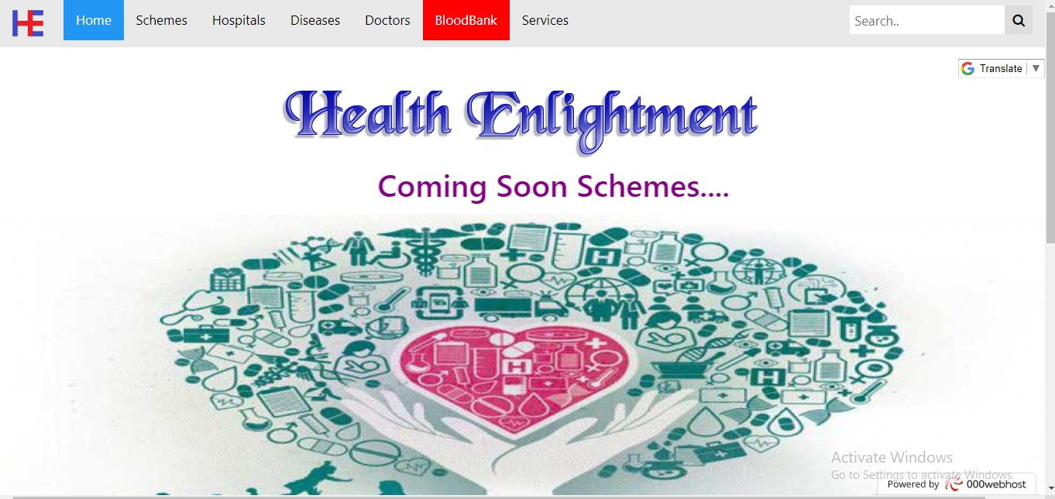

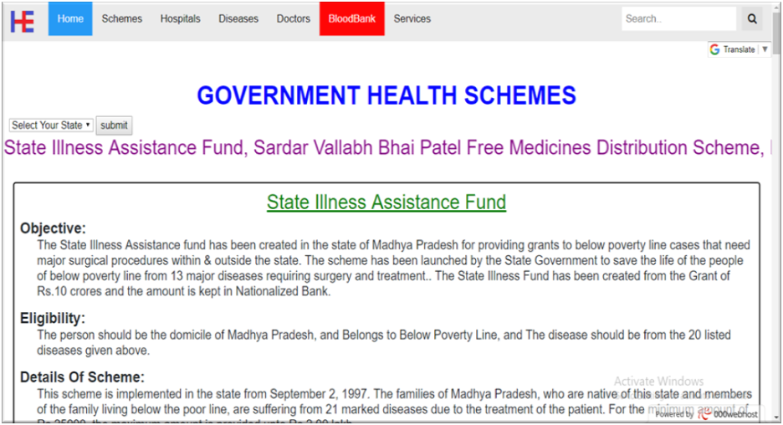

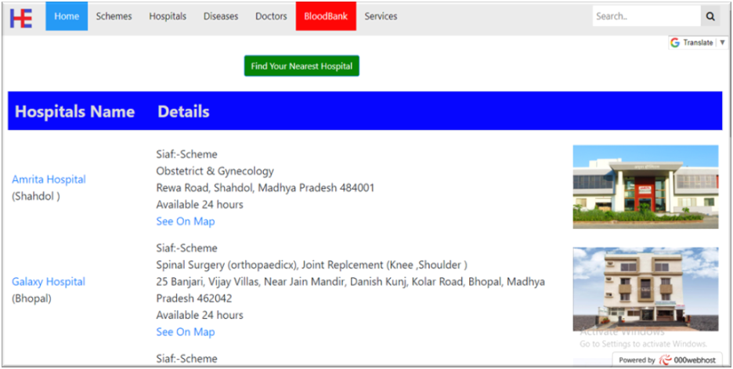

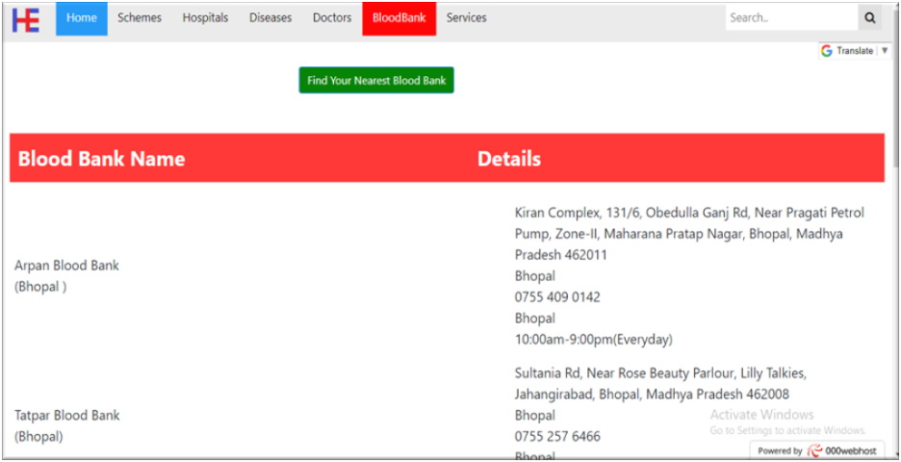

Chapter VII

Conclusion:
We conclude that from the intriguing journey of the project development we gained an insight of various aspects of software development. It was most inspiring to be guided by the software developer and the project manager who were enthusiastic and willing to share their career experiences. It was a thought-provoking experience in learning about the various web-technologies available in PHP to develop online applications. The intellectually stimulating teaching and guidance gave us a unique opportunity to observe for ourselves the practical aspects of software engineering.
We would like to thank all those who were directly or indirectly involved in this training period.
System Features:
System satisfies all the requirements for which the company developed the system. System has strong security. System is fully GUI based. It is easy to operate and user-friendly.
Working on the project was a good experience. Working together in teams helped us to communicate better. We understand the importance of planning and designing as a part of software development.
The concept of peer-reviews helped to rectify the problems as and when they occurred and also helped us to get some valuable suggestions that were incorporated by us. Developing the project has helped us to gain some experience on real time development procedures.
Suggestion for further development:
System required sufficient RAM and faster server to run the application properly.

